<Tools> <Mailmerge> :- Wizard starts
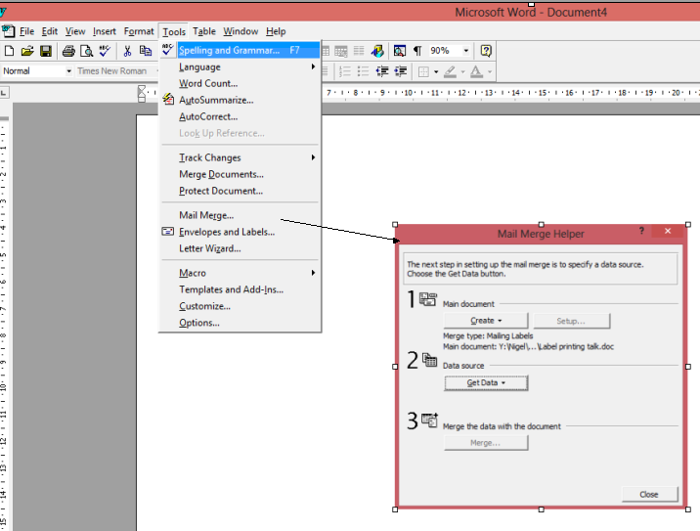
Main document create button, choose Mailing Labels, choose new main document

Press get data button and open data source.
Browse for your spreadsheet.
Choose entire spreadsheet.
Set up main document.
The Label option window opens:- Choose the correct label format from ref number.

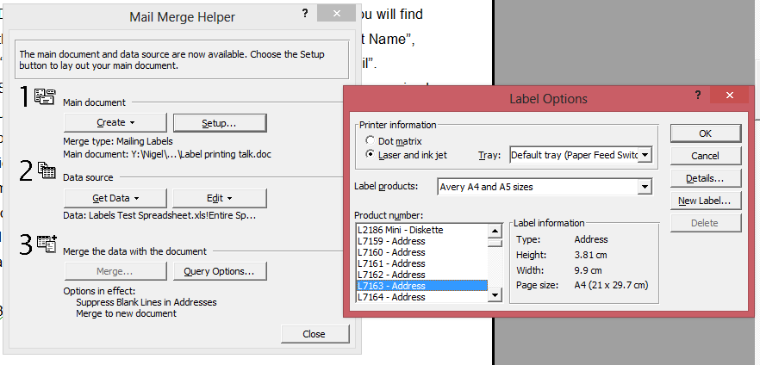

The create labels window opens :- (Insert the fields you want in the order you want
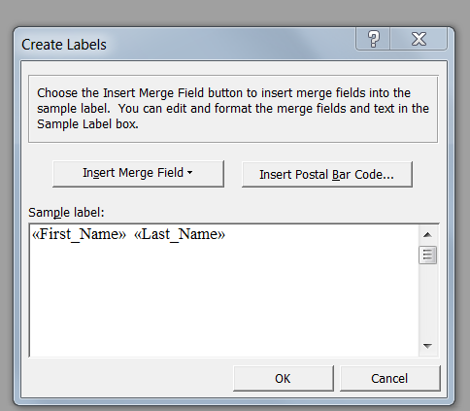
Mailmerge helper window re-opens
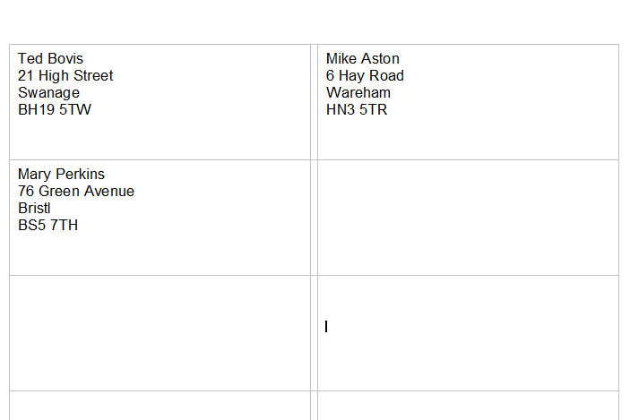
Click merge
Labels appear as a document

